**National University of Computer and Emerging Sciences**



Lab Manual #9

Programming Fundamentals

(Section BSE-1A)

|  |  |
| --- | --- |
| Course Instructor | Ms. Anoosha Khan |
| Lab Instructor(s) | Ms.Samia Akhter  Mr. Wajahat Ali Khan |
| Section | BSE-1A |
| Semester | Fall 2022 |

Department of Computer Science

FAST-NU, Lahore, Pakistan

# Objectives

The objectives of this lab are to cover the following:

* To learn Simple Functions
* Functions with parameter
* Functions with Loops
* Arrays
* Passing arrays to function
* Linear searching

**Question#1**

Write a function which takes 5 numbers in array1, copies them in array2, updates array2 by saving square of each number and displays both arrays (Make sure you implement all the requirements in separate loops i.e. 1st loop for input, 2nd for copying data, 3rd for saving square and 4th for display). Sample output is given below:

|  |
| --- |
| Array1 Array2  4 16  9 81  7 49  2 4  5 25 |

## Question#2

**Write a**  program that will print the frequency of the key in the array.

For example:

|  |  |  |  |  |  |
| --- | --- | --- | --- | --- | --- |
| 1 | 2 | 1 | 1 | 4 | 9 |

If array =

Then for key = 1, the program should print 3

Key = 2, the program should print 1

Key = 10, the program should print 0.

## Question#3

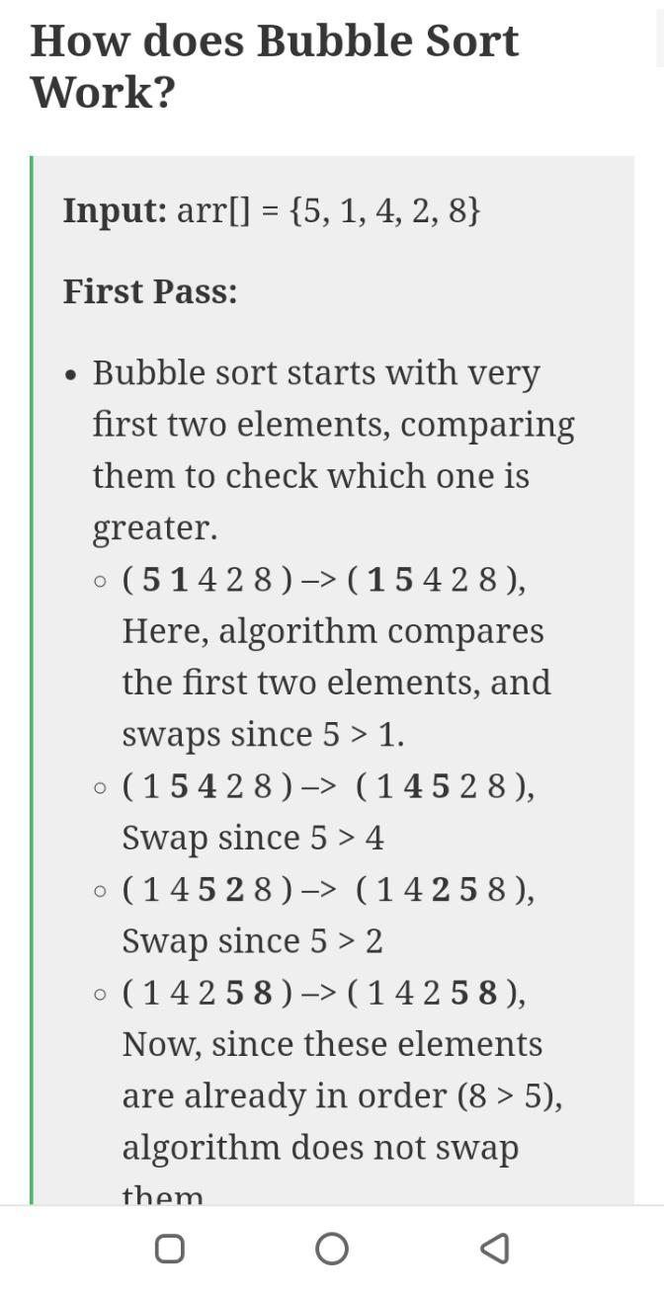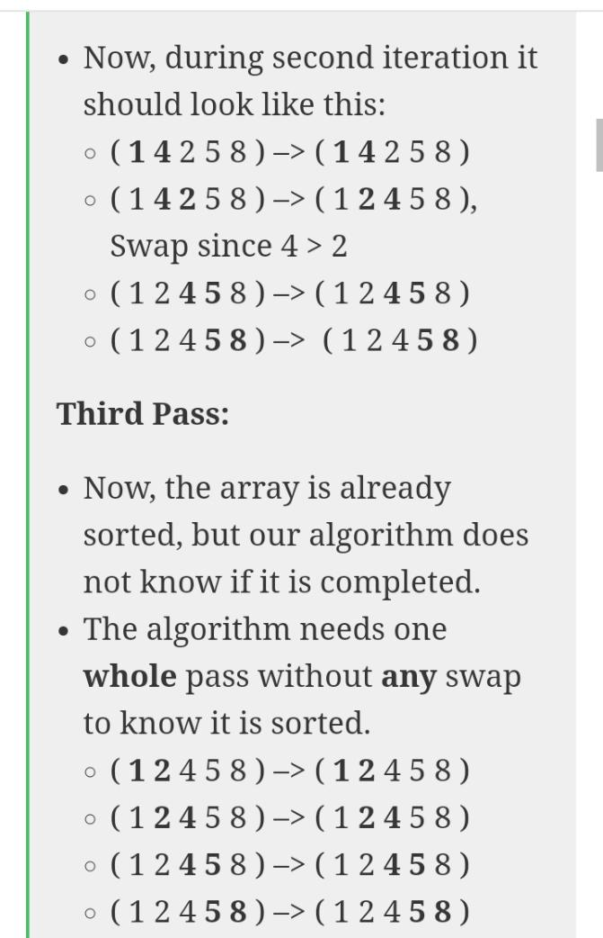Write a function **sortArray(int nums[ ], int size)** that sort a given array of 0s, 1s and 2s. In the final array put all 0s first, then all 1s and all 2s in last. Complete this task by using bubble sort technique.

Input array:

|  |  |  |  |  |  |
| --- | --- | --- | --- | --- | --- |
| 0 | 1 | 2 | 2 | 1 | 0 |

Output:

|  |  |  |  |  |  |
| --- | --- | --- | --- | --- | --- |
| 0 | 0 | 1 | 1 | 2 | 2 |

## Question#4

Write a C++ function that takes a integer array, size of array and an integer n as parameter and right rotate the array by n positions.

***void RotateArray(int array[], int size, int n)***

**Example:**

**Input:**

**Array**: 1,3,5,7,9,2,4,6,8

**Size**: 9

**n**: 2

**Output:**

6,8,1,3,5,7,9,2,4

**Question#5**

**Note: Use const int Size global variable**

Write a program that declare an int array of size N inside the main function. Write the following functions for this array:

1. int Find2Largest(int arr[])- The function returns the second largest element of an array.
2. void findMinMax(int arr[], int &min, int &max). This function should store the min and max value in the relevant variables which are passed by reference to the function. . .
3. evenSort(int arr[]). function to separate even and odd numbers of an array of integers. Put all even numbers first, and then odd numbers.
4. CheckFrequency(int arr[]) - the function will take an array as input and print the frequency of each element of an array.
5. searchData(int arr[], int key). This function should search the key using linear search technique and return the index. If key isn't available in the array, then return -1.

.

## 

.